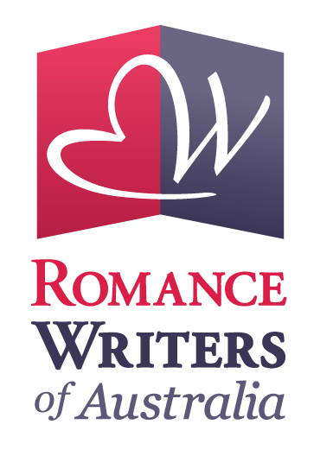ONLINE WORKSHOP LAB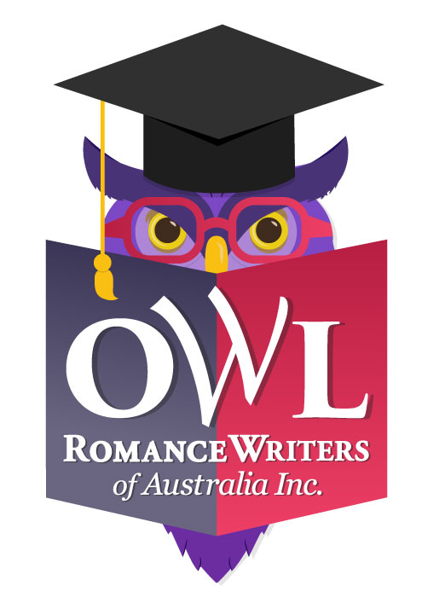
Expression of Interest

If you've ever considered presenting an OWL workshop but found that your course doesn't easily fit the standard four-week structure, you're in luck, because Romance Writers of Australia is looking to expand the OWL (Online Writing Lab) workshop program.

All concepts will be considered for one day and weekend courses, and courses for longer than four weeks, as well as ongoing on-demand courses (meaning available for participants to study at their own pace, at any time, not necessarily with presenter input or feedback, however this might be an optional extra). Courses will be required to be delivered on the RWA learning platform, Moodle and to complement the regular OWL program in 2018.

Any questions? Please contact Pauline Johnston at owlsinfo@romanceaustralia.com

Otherwise, please complete the following details and email this form, by the 30 October 2017, to: owlsinfo@romanceaustralia.com.

Presenter Details

Name:
Email:
Phone:

Course Details

Course Description: Tell us in detail, about your Course and your qualifications to teach it. How will participants benefit by doing your course? What can they expect to learn? What makes it unique?

Duration of course (eg. one day, weekend, ten weeks etc):

What would be your preferred delivery date: If your preference is for on-demand delivery please advise here otherwise please nominate your top three preferred delivery dates.

What form will lesson material take: (eg. pdf, word doc, audio file, YouTube video, other):

Frequency of lesson material dissemination: (eg. once only at the begining of the course, once a week etc):

Will you provide feedback/evaluation of homework to participants and if so how and when:

Will there be live interaction with you (eg. live chat session) and if so, how and when will this take place:

What is your recommended cost of workshop (inclusive of GST) of which you will receive 75% while RWA receives 25%:

Thank you - we'll be in touch!

