ONLINE WORKSHOP LAB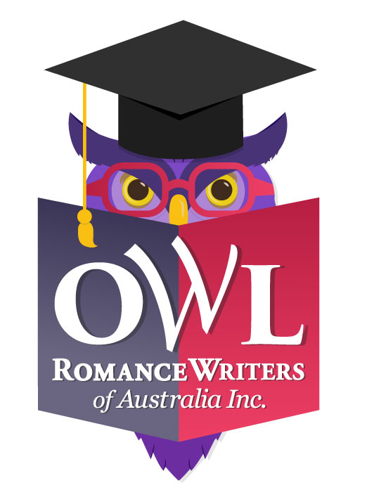
Proposal to Present a Four Week Workshop In 2018

Romance Writers of Australia is looking to offer our members a series of online workshops in 2018, through its Online Writing Lab (OWL). OWL events will be hosted, facilitated and promoted by RWA on a 75/25 profit-share arrangement with the presenter (the greater amount being the presenter’s).

We would like to invite interested RWA members and non-members to apply to conduct a workshop online through RWA in the 2018 OWL calendar.

The calendar of online courses will run from January to December.

RWA members and non-members can register for any or all of the workshops in the calendar using RWA’s established online registration and payment facility. The four week/one month long workshops are fixed at AU$55 ($50 plus GST) each for members, and AU$88 ($80 plus GST for non-members.

The workshop presenter will conduct their workshop during their allotted month using the RWA Moodle platform.

For the 75% the presenter will:
- Develop a four-week course suited for delivery online, via Moodle, containing content that is not generally (and freely) available (and content to which you hold copyright);
- Provide all necessary learning resources for participants in a timely fashion;
- Liaise with participants on all matters related to the course content;
- Interact with participants, respond to questions, and provide feedback on any materials forming part of the course (ends at the recognised conclusion of the workshop);
- Invoice RWA for your share of the revenue (template is provided, or you may use your own);
- Declare all income earned per the requirements of the ATO; and
- Secure all clearances for the use of copyright material in your workshop.

For its 25% RWA will manage:
- Online registration: We’ll send you a list of confirmed/paid participants prior to your commencement date;
- Payment: RWA will coordinate payments on your behalf and send you a reconciliation with your (75%) share of the revenue;
- Venue: RWA will provide a dedicated, password-controlled ‘room’ (this is closed on completion of the workshop);
- Promotion: RWA will include the event in Hearts Talk Magazine, a blog post on the RWA website, social media promotion and an announcement in the official RWA author writing groups.
- Participant tech support: We’ll provide login instructions to registrants and deal with technical support prior to the commencement of, and throughout the workshop, as required.

RWA intends to create a balanced, interesting, exciting schedule that suits members of all stages of their writing career - aspiring, emerging and established.

You should only apply to deliver a workshop where you have a high level of skill or experience in the writing-related subject, technique or craft. Proposals are also welcomed in the areas of marketing, publishing, building a website, mindset, etc. Proposals with the most relevance and interest for members will be deemed most competitive.

The OWL Workshop proposal form (below) contains information that will help us choose between presenters in the event of over-subscription.

We hope that the Online Workshop Lab will prove to be popular, well-subscribed and a useful income option for presenters. Let’s work together to create something valuable and enriching for our members.

Any questions? Please contact Pauline Johnston at owlsinfo@romanceaustralia.com

Otherwise, please complete the following details and email it, by the 30 October 2017 closing date, to: owlsinfo@romanceaustralia.com

Presenter Details

Name:
RWA Member No if applicable:
Address:
Email:
Phone:

Course Details

Course title:

Do you wish to cap the number of participants? | Y/N | If so, how many?
Do you have a minimum number of participants required before you will run the course? | Y/N | If so, what is the minimum

Course Description: Tell us in detail, about your Course and your qualifications to teach it. How will participants benefit by doing your course? What can they expect to learn? What makes it unique?

Course Delivery

Duration of course: Courses are to run for four weeks, delivered on the RWA online learning platform, Moodle. Support is provided.

What are your preferred delivery dates: (Circle or highlight your top three preferences and if you only have one preference that’s okay; we will do what we can to accommodate)

Jan |Feb | Mar | Apr | May | Jun | Jul | Aug | Sept | Oct | Nov | Dec

In what format will your lesson material be delivered (eg. pdf, word doc, audio file, YouTube video, other):

When will you disseminate lesson material (eg. once a week, twice a week, etc.):

How and when will you provide feedback/evaluation of homework to participants:

Will there be live interaction with you (eg. live chat session?) If so, how and when will this take place:

How many hours of commitment is required of participants:

Please list any pre-course preparation/activities required or expected of participants:

Please list any prerequisites/prior knowledge expected of the participants:

Promotional Details

Promotional blurb - please provide a paragraph (no more than 300 words) about your course for us to use for promotional purposes to grab people’s attention:

Social Media: What are some social media (Facebook and Twitter) blurbs you might like to use to grab people’s attention:

Author bio: Please provide a short bio for promotional purposes, you're welcome to include a link to your website:

Author image: When emailing your proposal, please also attach a profile picture of yourself for promotional purposes.

Feature image: If you have a feature image representing your course that you would like us to consider for promotions purposes - for use as a blog banner/feature image that we can adapt for Facebook and Instagram, please attach this when you send your proposal. If you do not supply an image, the RWA website team will provide an image.

Pick me! Pick me!

I warrant that all the information above is true and correct at the time of proposal.

I understand that this proposal implies an offer to deliver the workshop as stated above on one of the preferred dates stated. If successful, I will receive an invitation to present from RWA and completion of that form (by the due date) represents a formal commitment to deliver.

I understand that RWA will make this event available for $88 ($80 + GST) for non-members and $55 ($50 + GST) for members for a four week (4 week) course and that RWA will retain 25%.

Name:

Date:

