ONLINE WRITING LAB (OWL)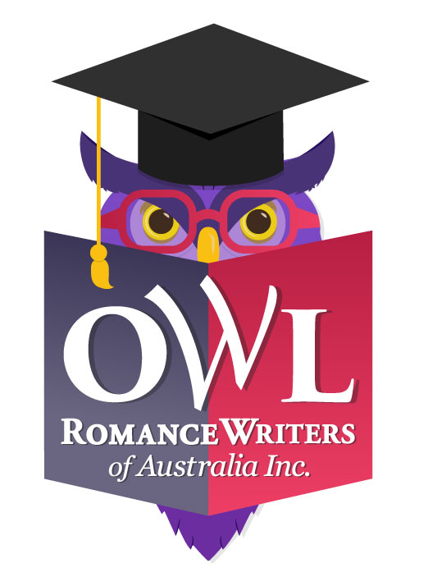
Expression of Interest

If you've ever considered presenting an OWL workshop but found that your course doesn't easily fit the standard four-week structure, you're in luck, because Romance Writers of Australia is looking to expand the OWL (Online Writing Lab) workshop program.

All concepts will be considered for one day and weekend courses, and courses for longer than four weeks, as well as ongoing on-demand courses, meaning that it would be available for participants to study at their own pace, at any time, not necessarily with presenter input or feedback, though this may be offered as an optional extra. Courses will be required to be delivered on the RWA learning platform, Moodle, and to complement the regular OWL program in 2020.

Any questions? Please contact Libby Iriks at owlsinfo@romanceaustralia.com

Otherwise, please complete the following details and email this form by the closing date,
18 October 2019, to: owlsinfo@romanceaustralia.com.

PRESENTER DETAILS
Name:
RWA member no (if applicable):
Address:
Email:
Phone:

COURSE DETAILS
Course title:
Course Description:
Tell us in detail, about your course and your qualifications to teach it. How will participants benefit by doing your course? What can they expect to learn? What makes it unique?
Duration of course:
What will the duration of your course be? E.g. one day, one weekend, ten weeks.
Courses are to be delivered on the RWA online learning platform, Moodle. Support is provided. If you are proposing a standard four-week OWL to be run during a scheduled month, please download and complete the OWL Information & Proposal Form instead.
What are your preferred delivery months?
If your preference is for on-demand delivery please advise here otherwise please nominate your top three preferred delivery dates.
In what format will your lesson material be delivered?
E.g. PDF, Word doc, audio file, YouTube video, other
How often will you disseminate lesson material?
E.g. once a week, twice a week, etc.
How and when will you provide feedback/evaluation of homework to participants?
Will there be live interaction with you? (e.g. live chat session?)
If so, how and when will this take place?
What is your recommended cost of workshop (inclusive of GST) of which you will receive 75% while RWA receives 25%:

Thank you - we'll be in touch!

