ONLINE WRITING LAB (OWL)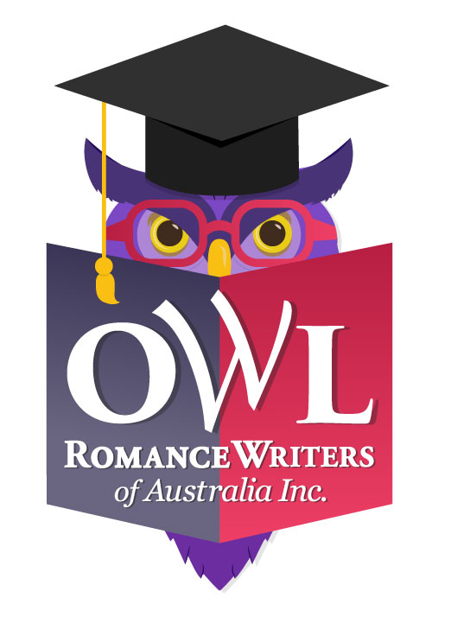
Proposal to present a four-week workshop in 2020

Romance Writers of Australia is looking to offer our members a series of online workshops in 2020, through its Online Writing Lab (OWL). OWL events will be hosted, facilitated and promoted by RWA on a 75/25 profit-share arrangement with the presenter (the greater amount being the presenter’s).

We would like to invite interested RWA members and non-members to apply to conduct a workshop online through RWA in the 2020 OWL calendar.

The calendar of online courses will run from February to November, though not during August as this is when RWA’s national convention is held.

RWA members and non-members can register for any or all of the workshops in the calendar using RWA’s established online registration and payment facility. The four-week-long workshops are fixed at AU$55 ($50 plus GST) each for members, and AU$88 ($80 plus GST for non-members.

The workshop presenter will conduct their workshop during their allotted month using the RWA Moodle platform.

For the 75% the presenter will:
- Develop a four-week course suited for delivery via the Moodle platform (alternative, preapproved platform indicated in the proposal document) and containing content that is not generally and freely available, and content to which they hold copyright;
- While RWA provides access to, and technical support when the Presenter chooses to deliver course via Moodle platform, setting up and technical support on any other platform the Presenter chooses to use is the responsibility of the Presenter;
- When the Presenter chooses to deliver the course on a platform other than Moodle, they must provide access to that platform to a member of the OWLs team, so they can continue to provide administrative support to course participants;
- Provide all necessary information packages to participants in a timely fashion, with relevant course materials/resources uploaded on the platform two days PRIOR to the course start date, ready to be accessed by participants from the start date;
- Liaise with participants on all matters related to the course content;
- Interact with participants, respond to questions, and provide feedback on any materials forming part of the course (ends at the recognised conclusion of the workshop);
- Invoice RWA for their share of the net revenue (template can be provided);
- Declare all income earned per the requirements of the ATO; and
- Secure all clearances for the use of copyright material in the workshop.

For its 25% RWA will manage:
- Online registration: RWA OWL Registrar will send the Presenter a list of confirmed/paid participants prior to the commencement date;
- Payments: RWA will coordinate Credit Card payments on behalf of the Presenter and send the reconciliation with the (75%) share of the net revenue;
- Participant tech support: RWA will provide technical support to registrants and the Presenter on the delivery method if the Presenter chooses to use the RWA Moodle platform. For other delivery platforms the Presenter will provide instructions to the OWL Registrar for dissemination to registrants;
- Venue: If using Moodle, RWA will provide a dedicated, password-controlled course for the Presenter and students. Any other “venue” is at the requirement of the Presenter and the Presenter will have responsibility for setting up and monitoring; and
- Promotion: RWA will include the event in Hearts Talk Magazine where timing permits, via Aspiring, Emerging and Established author groups, on the RWA Website and social media.

RWA intends to create a balanced, interesting, exciting schedule that suits members of all stages of their writing career—aspiring, emerging and established.

You should only apply to deliver a workshop where you have a high level of skill or experience in the writing-related subject, technique or craft. Proposals are also welcomed in the areas of marketing, publishing, building a website, mindset, etc. Proposals with the most relevance and interest for members will be deemed most competitive. This link gives an overview of RWA’s expectations for your training proposal, and how to create a great OWL.

The OWL proposal form (below) contains information that will help us choose between presenters in the event of over-subscription.

We hope that the Online Writing Lab will prove to be popular, well-subscribed and a useful income option for presenters. Let’s work together to create something valuable and enriching for our members.

Any questions? Please contact Libby Iriks at owlsinfo@romanceaustralia.com

Otherwise, please complete the following details and email the form by the closing date,
18 October 2019, to: owlsinfo@romanceaustralia.com

PRESENTER DETAILS
Name:
RWA member no (if applicable):
Address:
Email:
Phone:

COURSE DETAILS
Course title:
Do you wish to cap the number of participants? | Y/N | If so, how many?
Do you have a minimum number of participants required before you will run the course? | Y/N | If so, what is the minimum?
Course Description:
Tell us in detail, about your course and your qualifications to teach it. How will participants benefit by doing your course? What can they expect to learn? What makes it unique?
Duration of course: Courses are to run for four weeks, delivered on the RWA online learning platform, Moodle. Support is provided. If your proposed course differs from this duration delivery method, please download and complete the OWL Expression of Interest Form instead.
What are your preferred delivery months?  Highlight your top three preferences. If you only have one preference that’s okay; we will do what we can to accommodate. | Feb | Mar | Apr | May | Jun | Jul | Sept | Oct | Nov
In what format will your lesson material be delivered?
E.g. PDF, Word doc, audio file, YouTube video, other
How often will you disseminate lesson material?
E.g. once a week, twice a week, etc.
How and when will you provide feedback/evaluation of homework to participants?
Will there be live interaction with you? (e.g. live chat session?)
If so, how and when will this take place?
How many hours of commitment is required of participants?
Please list any pre-course preparation/activities required or expected of participants?
Please list any prerequisites/prior knowledge expected of the participants?
PROMOTIONAL DETAILS
Promotional blurb
Please provide a paragraph (no more than 300 words) about your course for us to use for promotional purposes.
Social Media
What are some social media (Facebook and Twitter) blurbs you might like us to use to grab people’s attention?
Author bio
Please provide a short bio for promotional purposes. You are welcome to include a link to your website.
Author image
When emailing your proposal, please also attach a profile picture of yourself for promotional purposes.
Feature image
If you have a feature image representing your course that you would like us to consider for promotional purposes—for use as a blog banner/feature image that we can adapt for Facebook and Instagram—please attach this when you send your proposal. If you do not supply an image, the RWA website team will create an image.

Pick me! Pick me!

I warrant that all the information above is true and correct at the time of proposal.

I understand that this proposal implies an offer to deliver the workshop as stated above on one of the preferred dates stated. I understand that if my proposal is accepted, I will receive an invitation to present from RWA and will be required to sign a formal Agreement (by a stipulated due date) that represents a commitment to deliver.

I understand that RWA will make this event available for $88 ($80 + GST) for non-members and $55 ($50 + GST) for members for a four-week course and that RWA will retain 25%.

Please sign below and return with your author image by 18 October 2019 to owlsinfo@romanceaustralia.com.

Name:

Date:

