Manuscript Title: Big Bad Romance Book

Sub-Genre: Contemporary Romance

Word count of completed manuscript: 90,000 words

This is how your synopsis or setup should look in RWA contests. The synopsis or setup must start on a new page after the title page (use a page break; do not tab or press enter to get to a new page). Use 12 point New Times Roman or Courier New font. The text must be double spaced. The margins should be 2.54cm all around (top, bottom, left and right) which is the default setting on Word. The entry is left-aligned (not fully justified). Put italics in italics and bold text in bold.
The indents to indicate a new paragraph are 1.27cm (Word default.) Your synopsis/set up should look exactly like this.
The entry title, sub-genre or line and page numbering all appear in the top right corner of your header, starting on page 1 on the first page of your synopsis/setup and continuing on for the rest of the entry. Don’t number the cover page. Do not start renumbering on either the synopsis or manuscript sections of your entry. Do not put your name in the header or title page of any contest entry, or anywhere else in your entry. (See contest conditions.)
Please save your document in Microsoft Word format only.
These guidelines are a summation of the standard format for a professional-looking submission to a publisher. We expect contest entrants to adhere to these guidelines and present their entries accordingly. A penalty will apply if an entry is not formatted correctly when entered into any of our contests. (See contest conditions.)
If in doubt as to how to mirror the look of this document, please contact the Contest Coordinator.
The manuscript part of the entry will start on a new page (use a page break; do not tab or press enter to get to a new page). Please see below for further instructions.

Chapter One
Please start the manuscript part of your entry on a new page (use a page break). This is the standard format for RWA contests. Your entry should look like these pages of instructions.
The entry title, sub genre or line and page numbering all appear in the top right corner of your header. Do not put your name in the header of any contest entry, or anywhere else in your entry (see contest conditions).
Text is aligned left (not fully justified). Use 12-point Courier New or Times New Roman font only. Double space your lines.
Begin new chapters on a new page, by using a Page Break, and start them about a third of the way down a page. Centre your chapter title (as at the beginning of this example).
Indent the first line of each paragraph to 1.27 cm, Word document default. Do not leave an extra line or extra spacing between paragraphs. The indent indicates the beginning of a new paragraph. To indicate a section break, leave an extra line (see the white gap between lines immediately following).

Alternatively, use:
***
*** is recommended for a section break at the end or beginning of a page, where it’s difficult to see a blank line.
‘What should I do for dialogue?’ asked the by-now-confused entrant.
‘Indent as for a paragraph and use quotation marks,’ came the reply. ‘You can use single or double quotes, so long as you use the same throughout your entry. Punctuation marks are placed inside the quotation marks.’
To indicate that something should appear in italics, use italics.
Please save your document in Microsoft Word format only.
These guidelines are a summation of the standard format for a professional-looking submission to a publisher. We expect contest entrants to adhere to these guidelines and present their entries accordingly. A penalty will apply if an entry is not formatted correctly when entered into any of our competitions (see contest conditions).
If in doubt as to how to mirror the look of this document, please contact the Contest Coordinator.

Pictorial Guide

Page Margins
All page margins must be 2.54 cm on all sides which is the Word document default setting.

Go to the Layout tab in a word document open the margin section and your settings should look like this;
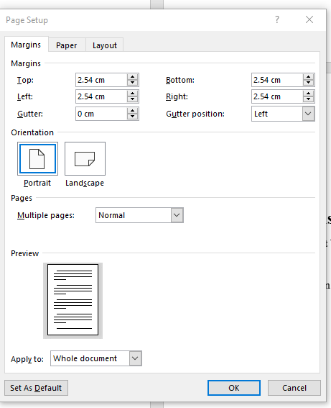

Paragraph Formatting
Your manuscript for an anthology must be double spaced with 1.27cm paragraph indents. Times New Roman or Courier New in 12 font only.
To adjust your settings go to the paragraph menu on the home page and click the arrow in the bottom right corner.
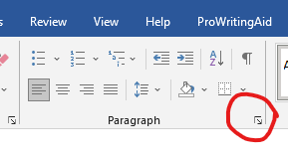.
Then check your settings.
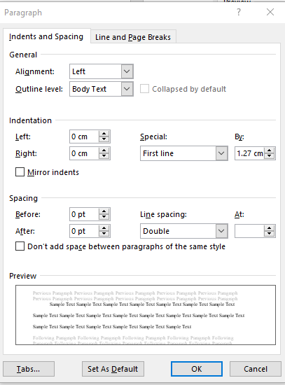
Start chapters on a new page (Use the page break found in the insert tab in word) one third of the way down.
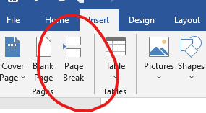
Header
Your header must all be on the same line as the number on the top right-hand corner. It must include the title, genre and page number. To alter a header go to the headers section on the Insert menu.
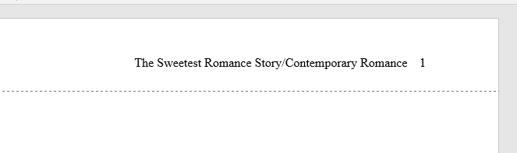
Your title page must not have a header. Go to the insert tab on a word document and find header. Marking different first page will leave it blank.
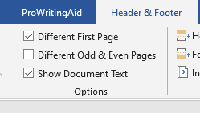

The first page of your story must be page 1, to achieve this in the page number section on the insert tab go to format numbers and start at 0

